**Objective:**

Covid 19 Tracker is an online application that keeps track of the details of vaccination as well as affected people for different states in India.

**Users of the System:**

1.   User

**Functional Requirements:**

* Build an application that allows users to view data on Covid 19 patients and vaccination rates for various Indian states.
* The application should have a side navigation panel with icon for Home, Shortcuts, People, Help and Settings.
* Each icon should display the page with the related contents.
* The search box should be provided so the user can search the information related to a particular state or district.
* Additional Information on Covid 19 should be given in Read More.
* The Vaccinated and Non-Vaccinated percentages should be mentioned on the bar.
* In India currently 54.9% of the people are vaccinated with 1st and 2nd dose.
* The covid 19 affected people should be differentiated by Confirmed, Active, Deceased, Recovered.
* Total number of people vaccinated doses should also be administered.
* A table should mention the number of people affected by Covid 19 by state-wise and should be differentiated by Confirmed, Active, Deceased, Recovered.
* India map should indicate the states affected by covid 19 with coloured effects and deliver the contents of the state.

**Output/ Post Condition:**

* Records Persisted

**Availability**

       99.99 % Availability

**Standard Features**

* Scalability
* Maintainability
* Usability
* Availability

**Browser Compatible**

All latest browsers

**Technology Stack**

**Front End** HTML & CSS

**Scripting** **Language** JavaScript

**Project Tasks:**

**API Endpoints:**

**USER**

**Action URL Method Response**

Get All Information – Home /home GET all information

Search – POST state/district to search

Read More – GET additional information on Covid 19

Shortcuts – GET the shortcuts information

People – GET the people information

Help – GET the help information

Settings – GET the help information

**Frontend:**

**User:**

1. **Home**: Design a home page (with the name home.html) where the information displays

* + Search box for searching the information related to a state or district.
  + The Vaccinated and Non-Vaccinated percentages.
  + Total number of people vaccinated doses.
  + A table that mentions the number of people affected by Covid 19 by state-wise and differentiated by Confirmed, Active, Deceased, Recovered.
  + India map indicating the states affected by covid 19 with coloured effects and delivering the contents of the state.
  + A side navigation panel with icon for Home, Shortcuts, People, Help and Settings.
  + Read More.

API endpoint Url: <http://localhost:8000/>home

Screenshot

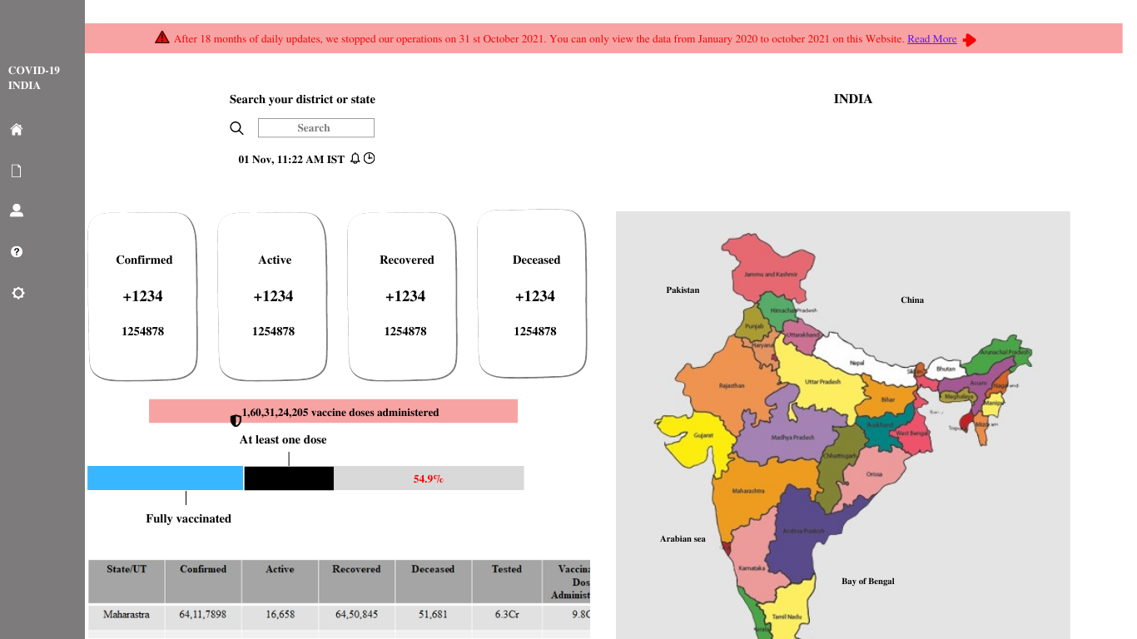

2. **Read More:** Design a page (with the name read.html) where the additional information on covid 19 is displayed

API endpoint Url: <http://localhost:8000/>home/read

Screenshot

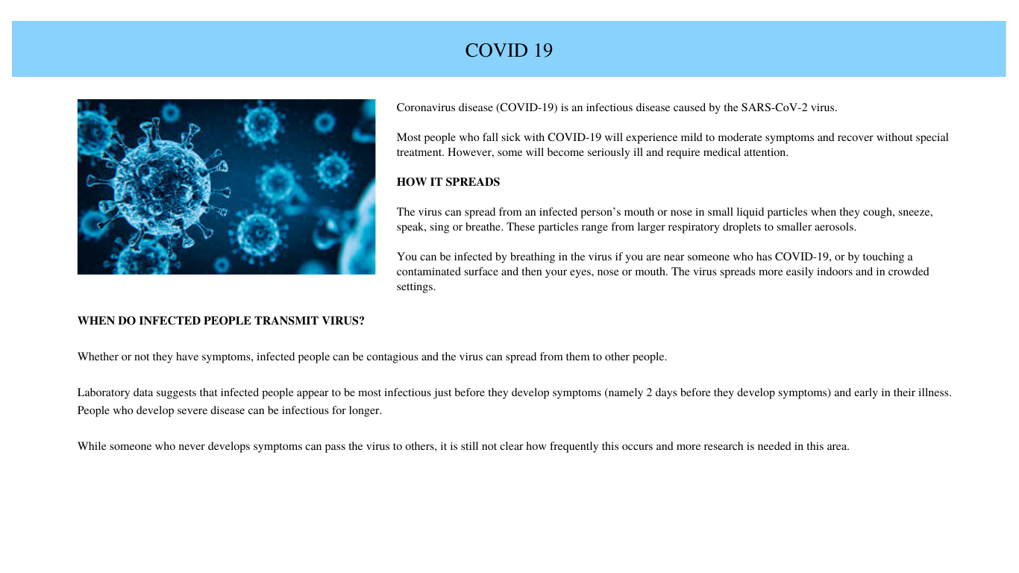

3. **Shortcuts:** Design a page (with the name shortcuts.html) to provide user with the shortcuts to use the application.

API endpoint Url: <http://localhost:8000/>home/shortcuts

Screenshot

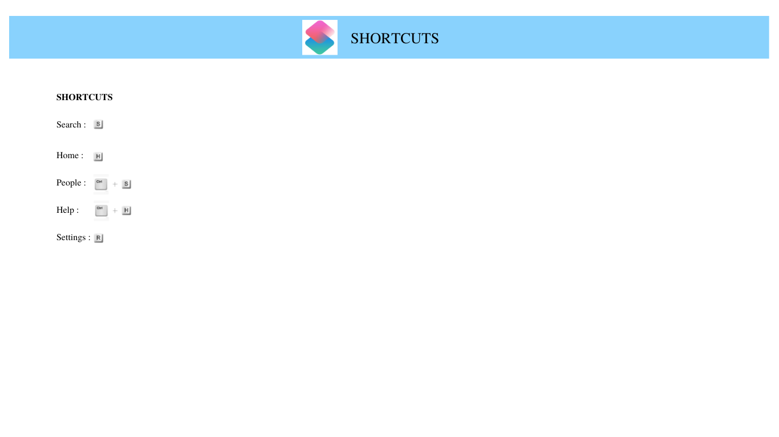

4. **People:** Design a page (with the name people.html) to provide user to search for the people at their service in a particular district or state.

API endpoint Url: <http://localhost:8000/>home/people

Screenshot

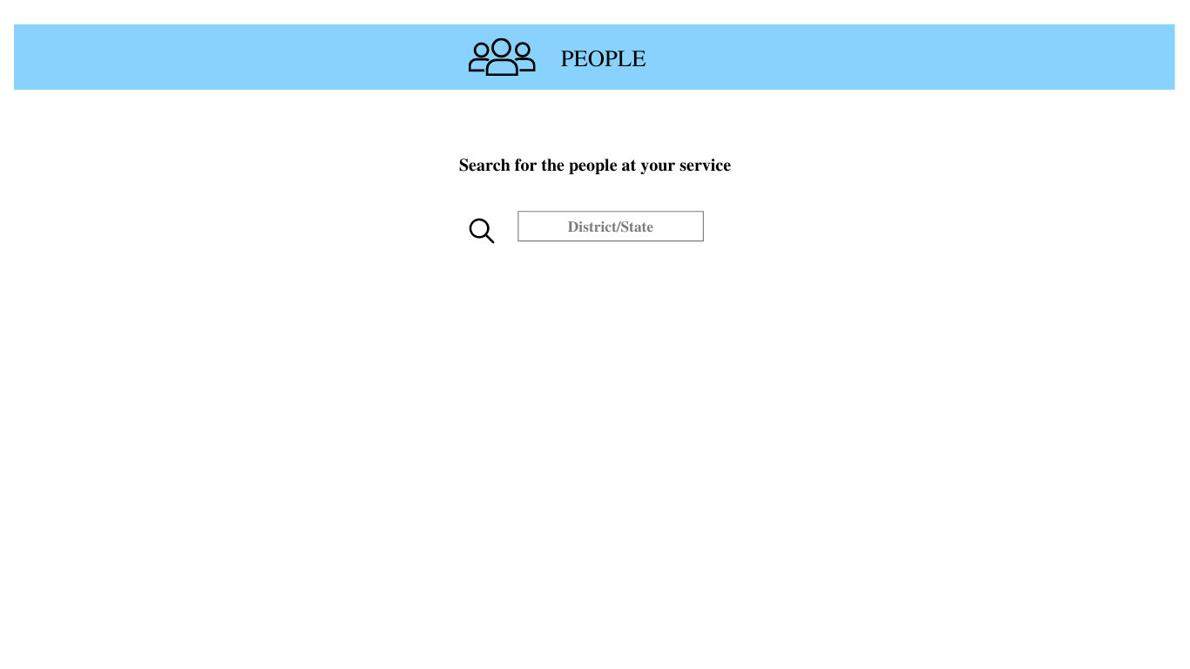

5. **Help:** Design a page (with the name help.html) to provide user with the information on how to use the COVID 19 Tracker Application. Also provide the user with FAQs on covid 19.

API endpoint Url: <http://localhost:8000/>home/help

Screenshot

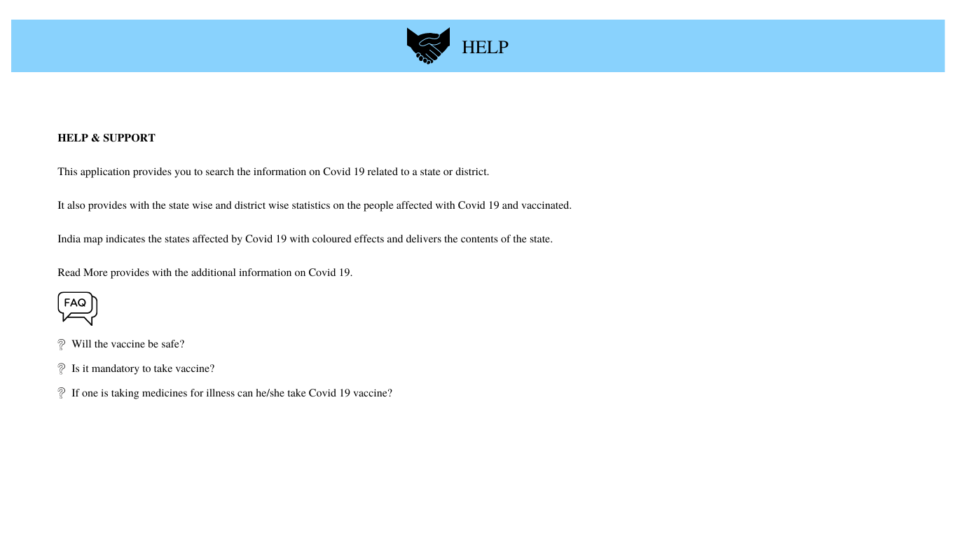

6. **Settings:** Design a page (with the name settings.html) where the user has options to change.

* + Language
  + Appearance
  + Mode
  + App Info

API endpoint Url: <http://localhost:8000/>home/settings

Screenshot

